1. Create a new process by invoking the appropriate system call. Get the process identifier of the currently running process and its respective parent using system calls and display the same using a C program.

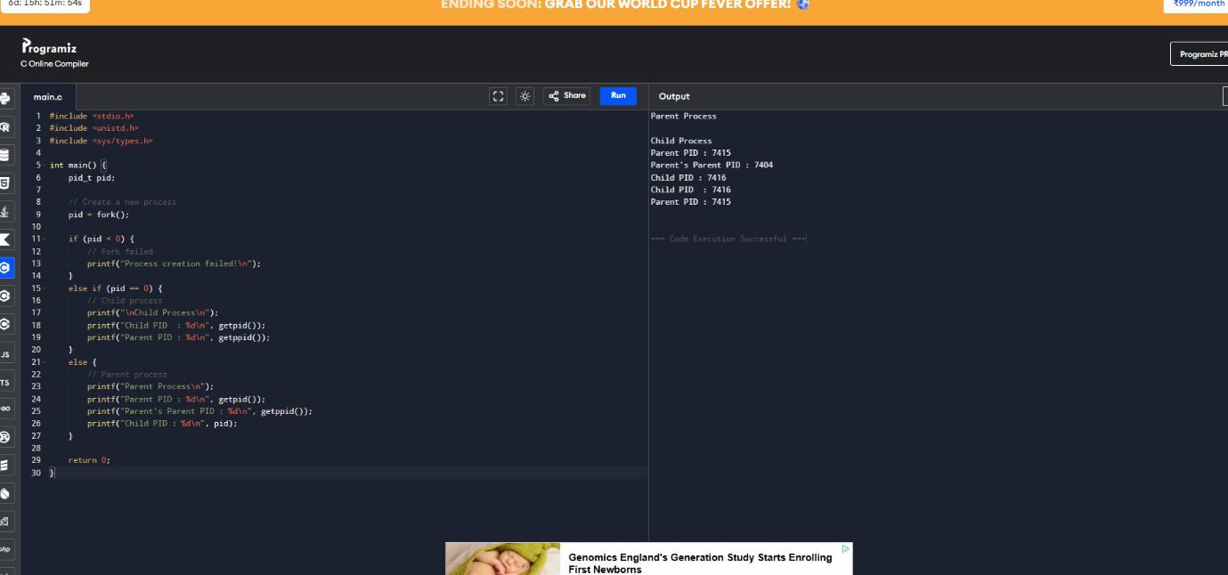

2. Identify the system calls to copy the content of one file to another and illustrate the same using a C program.

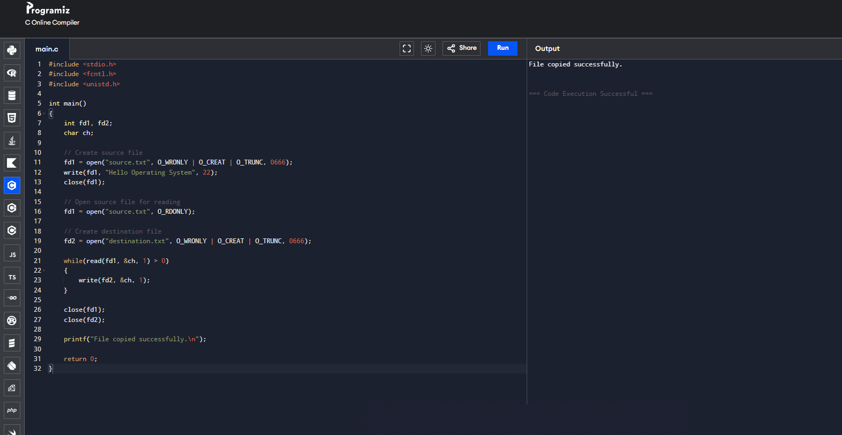___________________________________________________________________________

3. Design a CPU scheduling program with C using First Come First Served technique with the following considerations.
a. All processes are activated at time 0.
b. Assume that no process waits on I/O device
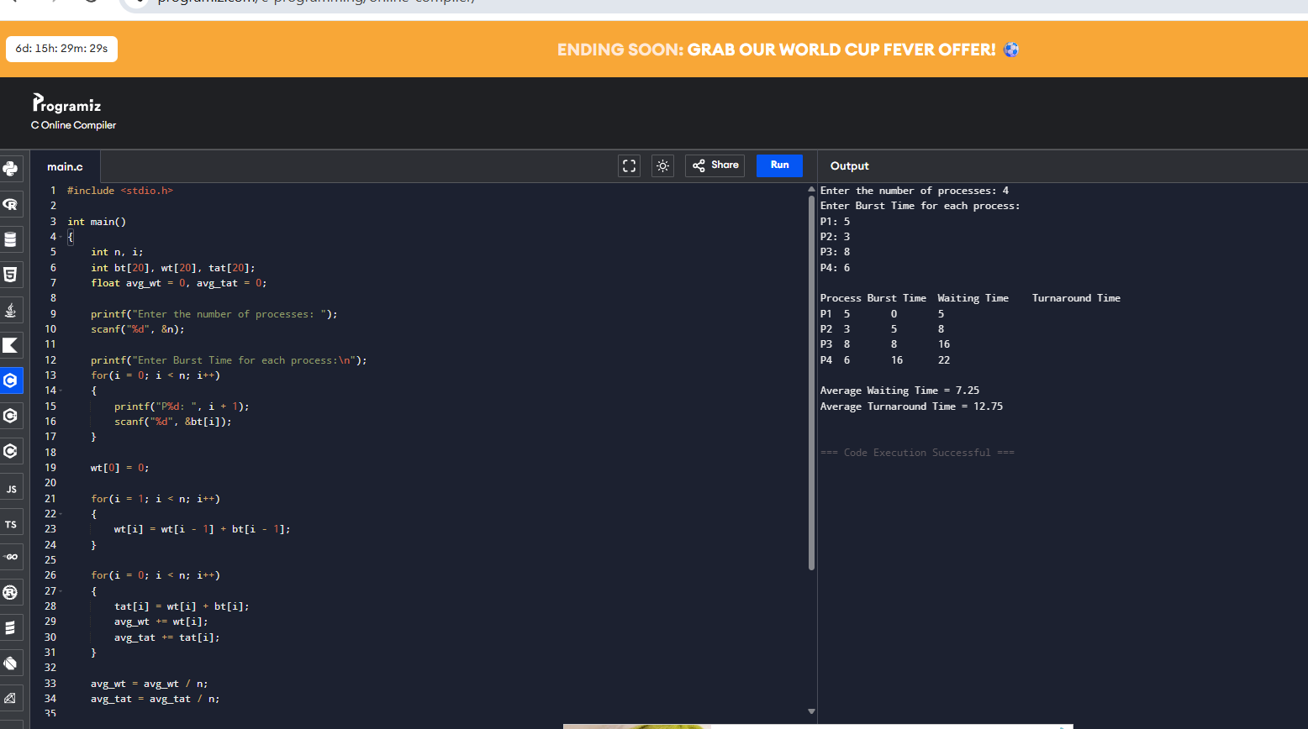___________________________________________________________________________
4. Construct a scheduling program with C that selects the waiting process with the smallest execution time to execute next

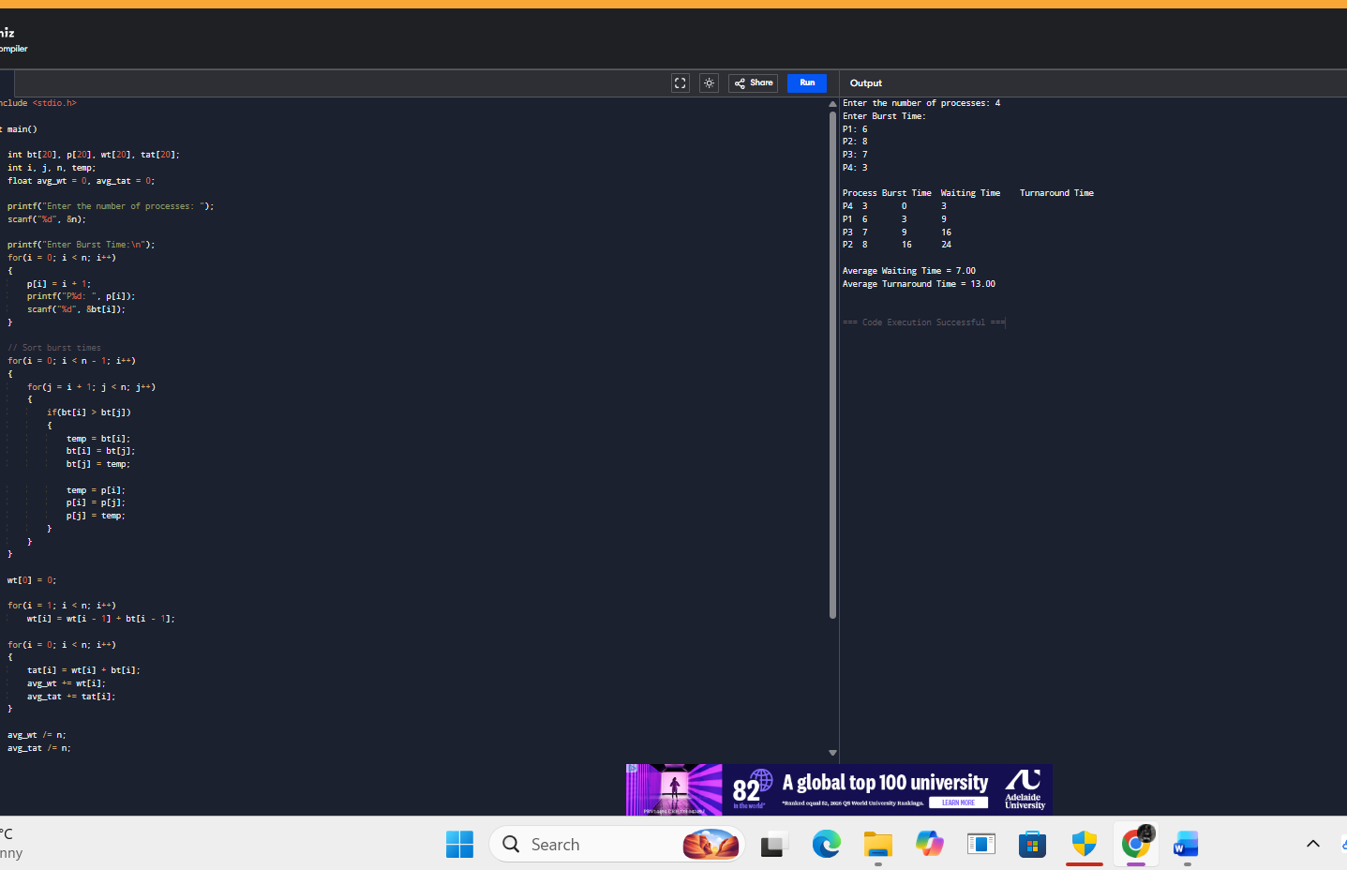

5. Construct a scheduling program with C that selects the waiting process with the highest priority to execute next.

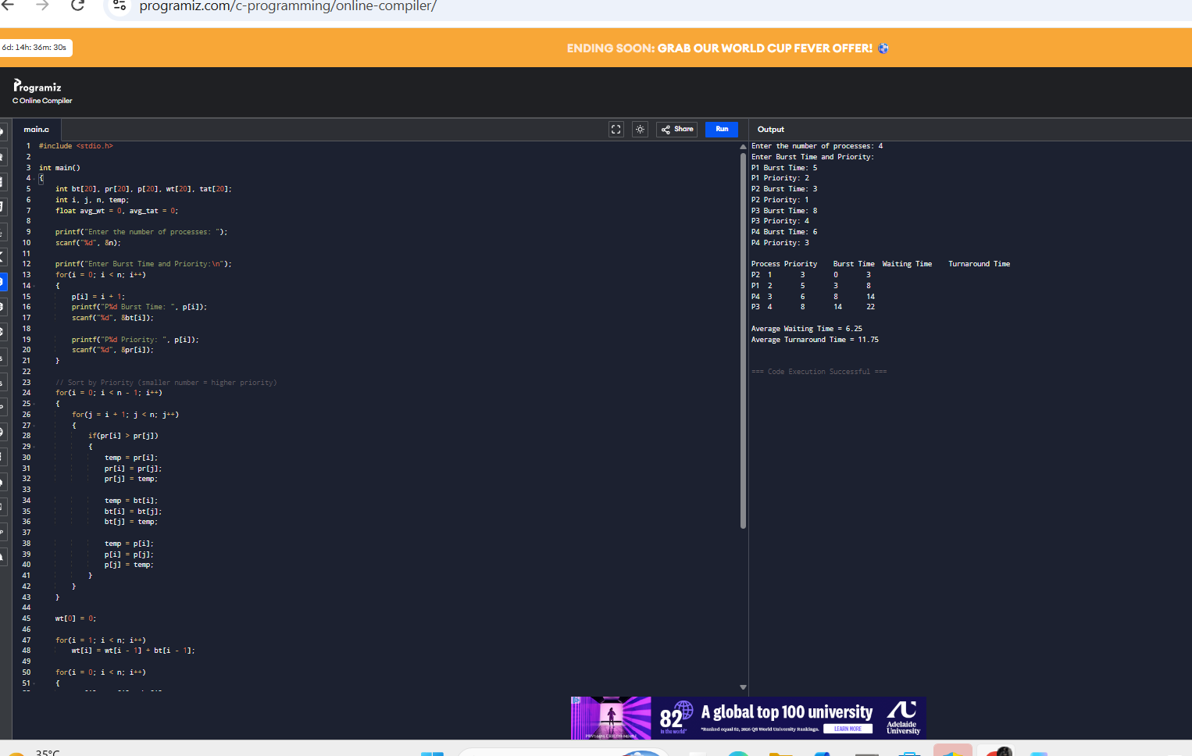

6. Construct a C program to implement preemptive priority scheduling algorithm 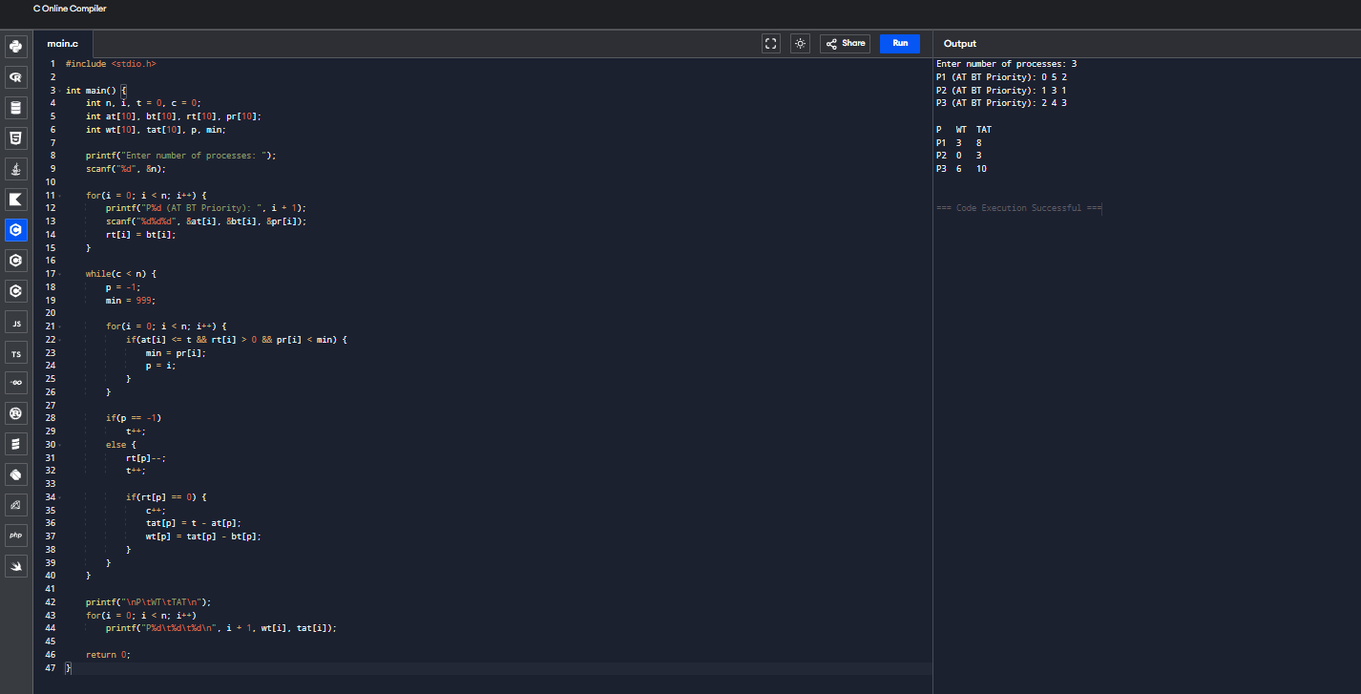

7. Construct a C program to implement a non-preemptive SJF algorithm.
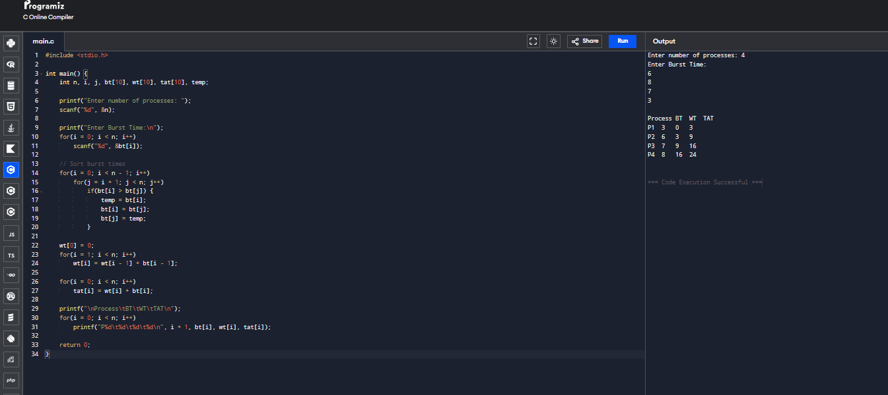

8. Construct a C program to simulate Round Robin scheduling algorithm with C.
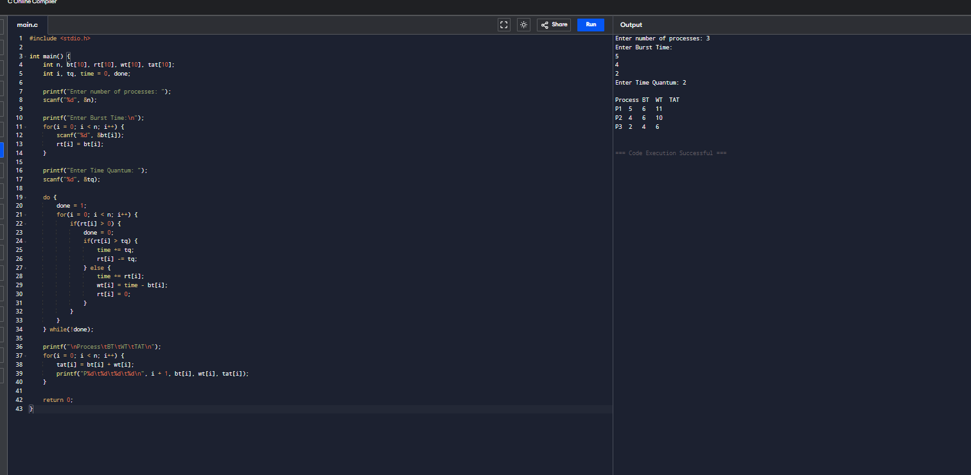

9. Illustrate the concept of inter-process communication using shared memory with
a C program.
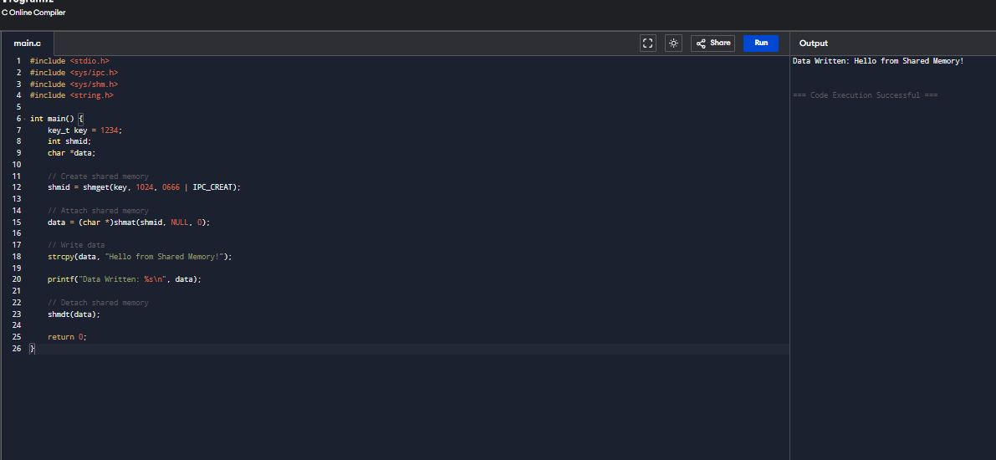

10. Illustrate the concept of inter-process communication using message queue with
a C program.
